**Introduction:**

The dataset here is about suicide rates in different countries. The goal here is simply to classify the attributes and find the correlation between them and suggest preferable generation of people who commits suicide.

**Attributes:**

1. Name of country

2. year

3. sex

4. age

5. suicides_no

6. population

7. suicides/100k population

8. country-year

9. HDI for year

10. gdp_for_year

11. gdp_per_capita($)

12.generation

**Methodology:**

The data set was classified using some classifier algorithm s.. Similarities were then analyzed between instances of individual classes and differences between instances of different classifiers.

**Dataset:**

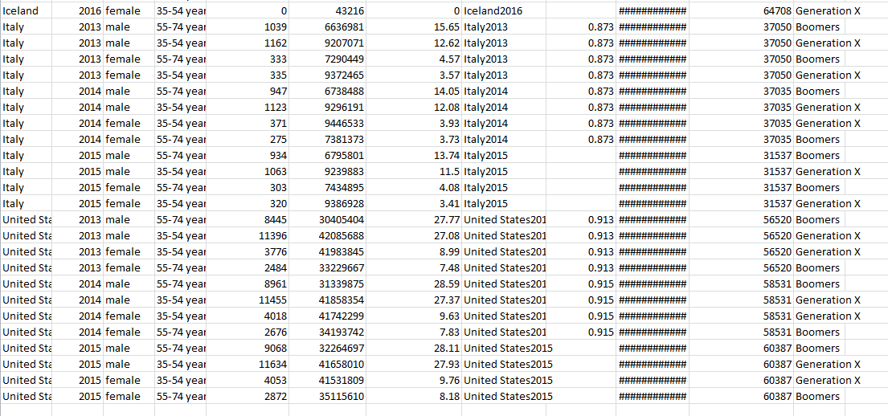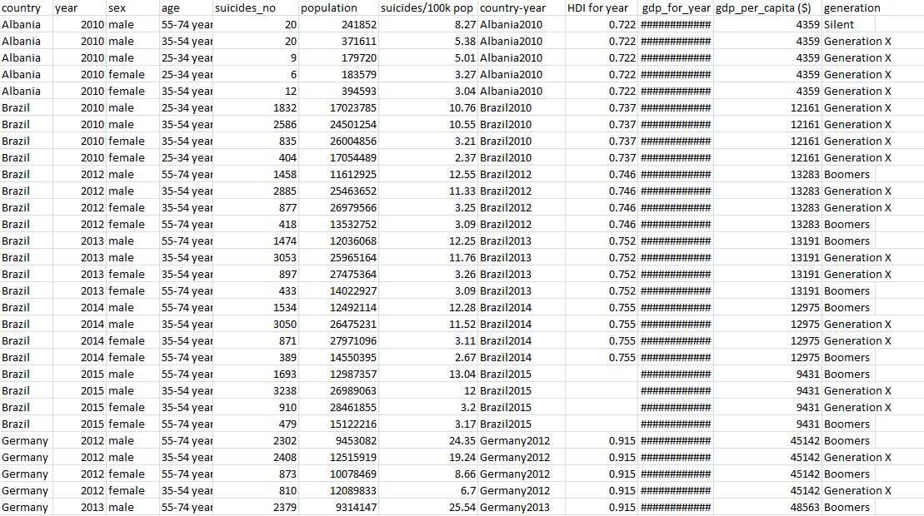

**Results:** The results are classified according to their generation.They are Boomers,Generation X and silent

**Naïve Bayes**

**Training Data:**

=== Run information ===

Scheme: weka.classifiers.bayes.NaiveBayes

Relation: suicide-weka.filters.supervised.instance.Resample-B0.0-S1-Z60.0-weka.filters.supervised.instance.Resample-B0.0-S1-Z60.0-no-replacement

Instances: 29

Attributes: 12

country

year

sex

age

suicides_no

population

suicides/100k pop

country-year

HDI for year

gdp_for_year ($)

gdp_per_capita ($)

generation

Test mode: evaluate on training data

=== Classifier model (full training set) ===

Naive Bayes Classifier

Class

Attribute Silent Generation X Boomers

(0.03) (0.53) (0.44)

=================================================================

country

Albania 1.0 3.0 1.0

Brazil 1.0 6.0 4.0

Germany 1.0 5.0 5.0

Iceland 1.0 3.0 2.0

Italy 1.0 2.0 3.0

United States 1.0 3.0 4.0

[total] 6.0 22.0 19.0

year

mean 0 2012.5781 2013.1731

std. dev. 0.2083 1.7382 0.7929

weight sum 0 16 13

precision 1.25 1.25 1.25

sex

male 1.0 12.0 9.0

female 1.0 6.0 6.0

[total] 2.0 18.0 15.0

age

55-74 years 1.0 1.0 14.0

35-54 years 1.0 15.0 1.0

25-34 years 1.0 3.0 1.0

[total] 3.0 19.0 16.0

suicides_no

mean 0 1934.1667 2082.9487

std. dev. 58.6111 1412.1508 2066.548

weight sum 0 16 13

precision 351.6667 351.6667 351.6667

population

mean 0 16388230.8594 14388026.2724

std. dev. 291346.3264 13382718.4698 10822757.2203

weight sum 0 16 13

precision 1748077.9583 1748077.9583 1748077.9583

suicides/100k pop

mean 0 12.4322 14.8876

std. dev. 0.1792 5.8023 8.5483

weight sum 0 16 13

precision 1.0752 1.0752 1.0752

country-year

Albania2010 1.0 3.0 1.0

Brazil2010 1.0 3.0 1.0

Brazil2012 1.0 1.0 3.0

Brazil2013 1.0 2.0 1.0

Brazil2014 1.0 2.0 2.0

Brazil2015 1.0 2.0 1.0

Germany2012 1.0 3.0 2.0

Germany2013 1.0 2.0 3.0

Germany2014 1.0 2.0 2.0

Germany2015 1.0 1.0 1.0

Iceland2012 1.0 1.0 1.0

Iceland2013 1.0 2.0 2.0

Iceland2014 1.0 1.0 1.0

Iceland2015 1.0 2.0 1.0

Iceland2016 1.0 1.0 1.0

Italy2013 1.0 1.0 1.0

Italy2014 1.0 2.0 2.0

Italy2015 1.0 1.0 2.0

United States2013 1.0 2.0 2.0

United States2014 1.0 1.0 3.0

United States2015 1.0 2.0 1.0

[total] 21.0 37.0 34.0

HDI for year

mean 0 0.8224 0.864

std. dev. 0.0036 0.0845 0.0643

weight sum 0 13 12

precision 0.0216 0.0216 0.0216

gdp_for_year ($)

11,926,953,259 1.0 3.0 1.0

2,208,871,646,203 1.0 3.0 1.0

2,465,188,674,415 1.0 1.0 3.0

2,472,806,919,902 1.0 2.0 1.0

2,455,993,625,159 1.0 2.0 2.0

1,802,214,373,741 1.0 2.0 1.0

3,543,983,909,148 1.0 3.0 2.0

3,752,513,503,278 1.0 2.0 3.0

3,890,606,893,347 1.0 2.0 2.0

3,375,611,100,742 1.0 1.0 1.0

14,292,008,745 1.0 1.0 1.0

15,548,321,544 1.0 2.0 2.0

17,304,033,021 1.0 1.0 1.0

16,942,247,374 1.0 2.0 1.0

20,304,098,101 1.0 1.0 1.0

2,130,491,320,659 1.0 1.0 1.0

2,151,732,868,243 1.0 2.0 2.0

1,832,868,490,534 1.0 1.0 2.0

16,691,517,000,000 1.0 2.0 2.0

17,427,609,000,000 1.0 1.0 3.0

18,120,714,000,000 1.0 2.0 1.0

[total] 21.0 37.0 34.0

gdp_per_capita ($)

mean 0 32216.1 40512.5538

std. dev. 622.5333 20707.4229 16694.4351

weight sum 0 16 13

precision 3735.2 3735.2 3735.2

Time taken to build model: 0 seconds

=== Evaluation on training set ===

Time taken to test model on training data: 0 seconds

=== Summary ===

Correctly Classified Instances 29 100 %

Incorrectly Classified Instances 0 0 %

Kappa statistic 1

Mean absolute error 0.0471

Root mean squared error 0.1078

Relative absolute error 13.8278 %

Root relative squared error 26.4983 %

Total Number of Instances 29

=== Detailed Accuracy By Class ===

TP Rate FP Rate Precision Recall F-Measure MCC ROC Area PRC Area Class

? 0.000 ? ? ? ? ? ? Silent

1.000 0.000 1.000 1.000 1.000 1.000 1.000 1.000 Generation X

1.000 0.000 1.000 1.000 1.000 1.000 1.000 1.000 Boomers

Weighted Avg. 1.000 0.000 1.000 1.000 1.000 1.000 1.000 1.000

**Test Data:**

=== Run information ===

Scheme: weka.classifiers.bayes.NaiveBayes

Relation: suicide-weka.filters.supervised.instance.Resample-B0.0-S1-Z60.0-weka.filters.supervised.instance.Resample-B0.0-S1-Z60.0-no-replacement

Instances: 29

Attributes: 12

country

year

sex

age

suicides_no

population

suicides/100k pop

country-year

HDI for year

gdp_for_year ($)

gdp_per_capita ($)

generation

Test mode: user supplied test set: size unknown (reading incrementally)

=== Classifier model (full training set) ===

Naive Bayes Classifier

Class

Attribute Silent Generation X Boomers

(0.03) (0.53) (0.44)

=================================================================

country

Albania 1.0 3.0 1.0

Brazil 1.0 6.0 4.0

Germany 1.0 5.0 5.0

Iceland 1.0 3.0 2.0

Italy 1.0 2.0 3.0

United States 1.0 3.0 4.0

[total] 6.0 22.0 19.0

year

mean 0 2012.5781 2013.1731

std. dev. 0.2083 1.7382 0.7929

weight sum 0 16 13

precision 1.25 1.25 1.25

sex

male 1.0 12.0 9.0

female 1.0 6.0 6.0

[total] 2.0 18.0 15.0

age

55-74 years 1.0 1.0 14.0

35-54 years 1.0 15.0 1.0

25-34 years 1.0 3.0 1.0

[total] 3.0 19.0 16.0

suicides_no

mean 0 1934.1667 2082.9487

std. dev. 58.6111 1412.1508 2066.548

weight sum 0 16 13

precision 351.6667 351.6667 351.6667

population

mean 0 16388230.8594 14388026.2724

std. dev. 291346.3264 13382718.4698 10822757.2203

weight sum 0 16 13

precision 1748077.9583 1748077.9583 1748077.9583

suicides/100k pop

mean 0 12.4322 14.8876

std. dev. 0.1792 5.8023 8.5483

weight sum 0 16 13

precision 1.0752 1.0752 1.0752

country-year

Albania2010 1.0 3.0 1.0

Brazil2010 1.0 3.0 1.0

Brazil2012 1.0 1.0 3.0

Brazil2013 1.0 2.0 1.0

Brazil2014 1.0 2.0 2.0

Brazil2015 1.0 2.0 1.0

Germany2012 1.0 3.0 2.0

Germany2013 1.0 2.0 3.0

Germany2014 1.0 2.0 2.0

Germany2015 1.0 1.0 1.0

Iceland2012 1.0 1.0 1.0

Iceland2013 1.0 2.0 2.0

Iceland2014 1.0 1.0 1.0

Iceland2015 1.0 2.0 1.0

Iceland2016 1.0 1.0 1.0

Italy2013 1.0 1.0 1.0

Italy2014 1.0 2.0 2.0

Italy2015 1.0 1.0 2.0

United States2013 1.0 2.0 2.0

United States2014 1.0 1.0 3.0

United States2015 1.0 2.0 1.0

[total] 21.0 37.0 34.0

HDI for year

mean 0 0.8224 0.864

std. dev. 0.0036 0.0845 0.0643

weight sum 0 13 12

precision 0.0216 0.0216 0.0216

gdp_for_year ($)

11,926,953,259 1.0 3.0 1.0

2,208,871,646,203 1.0 3.0 1.0

2,465,188,674,415 1.0 1.0 3.0

2,472,806,919,902 1.0 2.0 1.0

2,455,993,625,159 1.0 2.0 2.0

1,802,214,373,741 1.0 2.0 1.0

3,543,983,909,148 1.0 3.0 2.0

3,752,513,503,278 1.0 2.0 3.0

3,890,606,893,347 1.0 2.0 2.0

3,375,611,100,742 1.0 1.0 1.0

14,292,008,745 1.0 1.0 1.0

15,548,321,544 1.0 2.0 2.0

17,304,033,021 1.0 1.0 1.0

16,942,247,374 1.0 2.0 1.0

20,304,098,101 1.0 1.0 1.0

2,130,491,320,659 1.0 1.0 1.0

2,151,732,868,243 1.0 2.0 2.0

1,832,868,490,534 1.0 1.0 2.0

16,691,517,000,000 1.0 2.0 2.0

17,427,609,000,000 1.0 1.0 3.0

18,120,714,000,000 1.0 2.0 1.0

[total] 21.0 37.0 34.0

gdp_per_capita ($)

mean 0 32216.1 40512.5538

std. dev. 622.5333 20707.4229 16694.4351

weight sum 0 16 13

precision 3735.2 3735.2 3735.2

Time taken to build model: 0 seconds

=== Evaluation on test set ===

Time taken to test model on supplied test set: 0 seconds

=== Summary ===

Correctly Classified Instances 9 100 %

Incorrectly Classified Instances 0 0 %

Kappa statistic 1

Mean absolute error 0.0566

Root mean squared error 0.1093

Relative absolute error 16.6342 %

Root relative squared error 26.8901 %

Total Number of Instances 9

=== Detailed Accuracy By Class ===

TP Rate FP Rate Precision Recall F-Measure MCC ROC Area PRC Area Class

? 0.000 ? ? ? ? ? ? Silent

1.000 0.000 1.000 1.000 1.000 1.000 1.000 1.000 Generation X

1.000 0.000 1.000 1.000 1.000 1.000 1.000 1.000 Boomers

Weighted Avg. 1.000 0.000 1.000 1.000 1.000 1.000 1.000 1.000

**Result:**

**Cross-Validation:**

=== Run information ===

Scheme: weka.classifiers.bayes.NaiveBayes

Relation: suicide-weka.filters.supervised.instance.Resample-B0.0-S1-Z60.0-weka.filters.supervised.instance.Resample-B0.0-S1-Z60.0-no-replacement

Instances: 29

Attributes: 12

country

year

sex

age

suicides_no

population

suicides/100k pop

country-year

HDI for year

gdp_for_year ($)

gdp_per_capita ($)

generation

Test mode: 10-fold cross-validation

=== Classifier model (full training set) ===

Naive Bayes Classifier

Class

Attribute Silent Generation X Boomers

(0.03) (0.53) (0.44)

=================================================================

country

Albania 1.0 3.0 1.0

Brazil 1.0 6.0 4.0

Germany 1.0 5.0 5.0

Iceland 1.0 3.0 2.0

Italy 1.0 2.0 3.0

United States 1.0 3.0 4.0

[total] 6.0 22.0 19.0

year

mean 0 2012.5781 2013.1731

std. dev. 0.2083 1.7382 0.7929

weight sum 0 16 13

precision 1.25 1.25 1.25

sex

male 1.0 12.0 9.0

female 1.0 6.0 6.0

[total] 2.0 18.0 15.0

age

55-74 years 1.0 1.0 14.0

35-54 years 1.0 15.0 1.0

25-34 years 1.0 3.0 1.0

[total] 3.0 19.0 16.0

suicides_no

mean 0 1934.1667 2082.9487

std. dev. 58.6111 1412.1508 2066.548

weight sum 0 16 13

precision 351.6667 351.6667 351.6667

population

mean 0 16388230.8594 14388026.2724

std. dev. 291346.3264 13382718.4698 10822757.2203

weight sum 0 16 13

precision 1748077.9583 1748077.9583 1748077.9583

suicides/100k pop

mean 0 12.4322 14.8876

std. dev. 0.1792 5.8023 8.5483

weight sum 0 16 13

precision 1.0752 1.0752 1.0752

country-year

Albania2010 1.0 3.0 1.0

Brazil2010 1.0 3.0 1.0

Brazil2012 1.0 1.0 3.0

Brazil2013 1.0 2.0 1.0

Brazil2014 1.0 2.0 2.0

Brazil2015 1.0 2.0 1.0

Germany2012 1.0 3.0 2.0

Germany2013 1.0 2.0 3.0

Germany2014 1.0 2.0 2.0

Germany2015 1.0 1.0 1.0

Iceland2012 1.0 1.0 1.0

Iceland2013 1.0 2.0 2.0

Iceland2014 1.0 1.0 1.0

Iceland2015 1.0 2.0 1.0

Iceland2016 1.0 1.0 1.0

Italy2013 1.0 1.0 1.0

Italy2014 1.0 2.0 2.0

Italy2015 1.0 1.0 2.0

United States2013 1.0 2.0 2.0

United States2014 1.0 1.0 3.0

United States2015 1.0 2.0 1.0

[total] 21.0 37.0 34.0

HDI for year

mean 0 0.8224 0.864

std. dev. 0.0036 0.0845 0.0643

weight sum 0 13 12

precision 0.0216 0.0216 0.0216

gdp_for_year ($)

11,926,953,259 1.0 3.0 1.0

2,208,871,646,203 1.0 3.0 1.0

2,465,188,674,415 1.0 1.0 3.0

2,472,806,919,902 1.0 2.0 1.0

2,455,993,625,159 1.0 2.0 2.0

1,802,214,373,741 1.0 2.0 1.0

3,543,983,909,148 1.0 3.0 2.0

3,752,513,503,278 1.0 2.0 3.0

3,890,606,893,347 1.0 2.0 2.0

3,375,611,100,742 1.0 1.0 1.0

14,292,008,745 1.0 1.0 1.0

15,548,321,544 1.0 2.0 2.0

17,304,033,021 1.0 1.0 1.0

16,942,247,374 1.0 2.0 1.0

20,304,098,101 1.0 1.0 1.0

2,130,491,320,659 1.0 1.0 1.0

2,151,732,868,243 1.0 2.0 2.0

1,832,868,490,534 1.0 1.0 2.0

16,691,517,000,000 1.0 2.0 2.0

17,427,609,000,000 1.0 1.0 3.0

18,120,714,000,000 1.0 2.0 1.0

[total] 21.0 37.0 34.0

gdp_per_capita ($)

mean 0 32216.1 40512.5538

std. dev. 622.5333 20707.4229 16694.4351

weight sum 0 16 13

precision 3735.2 3735.2 3735.2

Time taken to build model: 0 seconds

=== Stratified cross-validation ===

=== Summary ===

Correctly Classified Instances 19 65.5172 %

Incorrectly Classified Instances 10 34.4828 %

Kappa statistic 0.3224

Mean absolute error 0.2447

Root mean squared error 0.4224

Relative absolute error 70.9783 %

Root relative squared error 102.8071 %

Total Number of Instances 29

=== Detailed Accuracy By Class ===

TP Rate FP Rate Precision Recall F-Measure MCC ROC Area PRC Area Class

? 0.000 ? ? ? ? ? ? Silent

0.563 0.231 0.750 0.563 0.643 0.335 0.712 0.716 Generation X

0.769 0.438 0.588 0.769 0.667 0.335 0.712 0.686 Boomers

Weighted Avg. 0.655 0.323 0.677 0.655 0.654 0.335 0.712 0.702

=== Confusion Matrix ===

a b c <-- classified as

0 0 0 | a = Silent

0 9 7 | b = Generation X

1. 3 10 | c = Boomers

**Decision Tree:**

**Training data:**

**=== Run information ===**

**Scheme: weka.classifiers.trees.J48 -C 0.25 -M 2**

**Relation: suicide-weka.filters.supervised.instance.Resample-B0.0-S1-Z60.0-weka.filters.supervised.instance.Resample-B0.0-S1-Z60.0-no-replacement**

**Instances: 29**

**Attributes: 12**

**country**

**year**

**sex**

**age**

**suicides_no**

**population**

**suicides/100k pop**

**country-year**

**HDI for year**

**gdp_for_year ($)**

**gdp_per_capita ($)**

**generation**

**Test mode: evaluate on training data**

**=== Classifier model (full training set) ===**

**J48 pruned tree**

**------------------**

**age = 55-74 years: Boomers (13.0)**

**age = 35-54 years: Generation X (14.0)**

**age = 25-34 years: Generation X (2.0)**

**Number of Leaves : 3**

**Size of the tree : 4**

**Time taken to build model: 0 seconds**

**=== Evaluation on training set ===**

**Time taken to test model on training data: 0 seconds**

**=== Summary ===**

**Correctly Classified Instances 29 100 %**

**Incorrectly Classified Instances 0 0 %**

**Kappa statistic 1**

**Mean absolute error 0**

**Root mean squared error 0**

**Relative absolute error 0 %**

**Root relative squared error 0 %**

**Total Number of Instances 29**

**=== Detailed Accuracy By Class ===**

**TP Rate FP Rate Precision Recall F-Measure MCC ROC Area PRC Area Class**

**? 0.000 ? ? ? ? ? ? Silent**

**1.000 0.000 1.000 1.000 1.000 1.000 1.000 1.000 Generation X**

**1.000 0.000 1.000 1.000 1.000 1.000 1.000 1.000 Boomers**

**Weighted Avg. 1.000 0.000 1.000 1.000 1.000 1.000 1.000 1.000**

**=== Confusion Matrix ===**

**a b c <-- classified as**

**0 0 0 | a = Silent**

**0 16 0 | b = Generation X**

1. **0 13 | c = Boomers**

**Test Set:**

=== Run information ===

Scheme: weka.classifiers.trees.J48 -C 0.25 -M 2

Relation: suicide-weka.filters.supervised.instance.Resample-B0.0-S1-Z60.0-weka.filters.supervised.instance.Resample-B0.0-S1-Z60.0-no-replacement

Instances: 29

Attributes: 12

country

year

sex

age

suicides_no

population

suicides/100k pop

country-year

HDI for year

gdp_for_year ($)

gdp_per_capita ($)

generation

Test mode: user supplied test set: size unknown (reading incrementally)

=== Classifier model (full training set) ===

J48 pruned tree

------------------

age = 55-74 years: Boomers (13.0)

age = 35-54 years: Generation X (14.0)

age = 25-34 years: Generation X (2.0)

Number of Leaves : 3

Size of the tree : 4

Time taken to build model: 0 seconds

=== Evaluation on test set ===

Time taken to test model on supplied test set: 0 seconds

=== Summary ===

Correctly Classified Instances 9 100 %

Incorrectly Classified Instances 0 0 %

Kappa statistic 1

Mean absolute error 0

Root mean squared error 0

Relative absolute error 0 %

Root relative squared error 0 %

Total Number of Instances 9

=== Detailed Accuracy By Class ===

TP Rate FP Rate Precision Recall F-Measure MCC ROC Area PRC Area Class

? 0.000 ? ? ? ? ? ? Silent

1.000 0.000 1.000 1.000 1.000 1.000 1.000 1.000 Generation X

1.000 0.000 1.000 1.000 1.000 1.000 1.000 1.000 Boomers

Weighted Avg. 1.000 0.000 1.000 1.000 1.000 1.000 1.000 1.000

=== Confusion Matrix ===

a b c <-- classified as

0 0 0 | a = Silent

0 5 0 | b = Generation X

0 0 4 | c = Boomers

**CrossValidation:**

=== Run information ===

Scheme: weka.classifiers.trees.J48 -C 0.25 -M 2

Relation: suicide-weka.filters.supervised.instance.Resample-B0.0-S1-Z60.0-weka.filters.supervised.instance.Resample-B0.0-S1-Z60.0-no-replacement

Instances: 29

Attributes: 12

country

year

sex

age

suicides_no

population

suicides/100k pop

country-year

HDI for year

gdp_for_year ($)

gdp_per_capita ($)

generation

Test mode: 10-fold cross-validation

=== Classifier model (full training set) ===

J48 pruned tree

------------------

age = 55-74 years: Boomers (13.0)

age = 35-54 years: Generation X (14.0)

age = 25-34 years: Generation X (2.0)

Number of Leaves : 3

Size of the tree : 4

Time taken to build model: 0 seconds

=== Stratified cross-validation ===

=== Summary ===

Correctly Classified Instances 29 100 %

Incorrectly Classified Instances 0 0 %

Kappa statistic 1

Mean absolute error 0

Root mean squared error 0

Relative absolute error 0 %

Root relative squared error 0 %

Total Number of Instances 29

=== Detailed Accuracy By Class ===

TP Rate FP Rate Precision Recall F-Measure MCC ROC Area PRC Area Class

? 0.000 ? ? ? ? ? ? Silent

1.000 0.000 1.000 1.000 1.000 1.000 1.000 1.000 Generation X

1.000 0.000 1.000 1.000 1.000 1.000 1.000 1.000 Boomers

Weighted Avg. 1.000 0.000 1.000 1.000 1.000 1.000 1.000 1.000

=== Confusion Matrix ===

a b c <-- classified as

0 0 0 | a = Silent

0 16 0 | b = Generation X

0 0 13 | c = Boomers

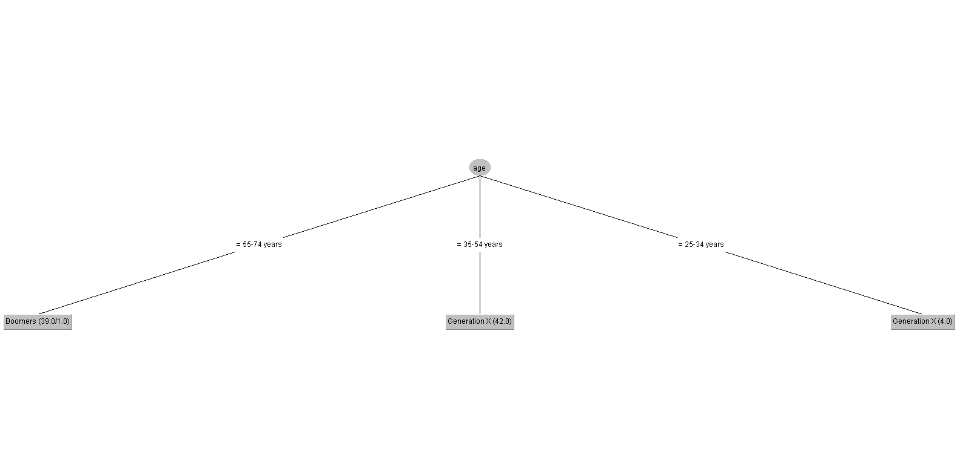

Classification via Regression

Training Data:

=== Run information ===

Scheme: weka.classifiers.meta.ClassificationViaRegression -W weka.classifiers.trees.M5P -- -M 4.0 -num-decimal-places 4

Relation: suicide-weka.filters.supervised.instance.Resample-B0.0-S1-Z60.0-weka.filters.supervised.instance.Resample-B0.0-S1-Z60.0-no-replacement

Instances: 29

Attributes: 12

country

year

sex

age

suicides_no

population

suicides/100k pop

country-year

HDI for year

gdp_for_year ($)

gdp_per_capita ($)

generation

Test mode: evaluate on training data

=== Classifier model (full training set) ===

Classification via Regression

Classifier for class with index 0:

M5 pruned model tree:

(using smoothed linear models)

LM1 (29)

LM num: 1

generation =

+ 0

Number of Rules : 1

Classifier for class with index 1:

M5 pruned model tree:

(using smoothed linear models)

LM1 (29/0%)

LM num: 1

generation =

1 * age=35-54 years,25-34 years

+ 0

Number of Rules : 1

Classifier for class with index 2:

M5 pruned model tree:

(using smoothed linear models)

LM1 (29/0%)

LM num: 1

generation =

1 * age=55-74 years

+ 0

Number of Rules : 1

Time taken to build model: 0.09 seconds

=== Evaluation on training set ===

Time taken to test model on training data: 0 seconds

=== Summary ===

Correctly Classified Instances 29 100 %

Incorrectly Classified Instances 0 0 %

Kappa statistic 1

Mean absolute error 0

Root mean squared error 0

Relative absolute error 0 %

Root relative squared error 0 %

Total Number of Instances 29

=== Detailed Accuracy By Class ===

TP Rate FP Rate Precision Recall F-Measure MCC ROC Area PRC Area Class

? 0.000 ? ? ? ? ? ? Silent

1.000 0.000 1.000 1.000 1.000 1.000 1.000 1.000 Generation X

1.000 0.000 1.000 1.000 1.000 1.000 1.000 1.000 Boomers

Weighted Avg. 1.000 0.000 1.000 1.000 1.000 1.000 1.000 1.000

=== Confusion Matrix ===

a b c <-- classified as

0 0 0 | a = Silent

0 16 0 | b = Generation X

1. 0 13 | c = Boomers

**Test Data:**

=== Run information ===

Scheme: weka.classifiers.meta.ClassificationViaRegression -W weka.classifiers.trees.M5P -- -M 4.0 -num-decimal-places 4

Relation: suicide-weka.filters.supervised.instance.Resample-B0.0-S1-Z60.0-weka.filters.supervised.instance.Resample-B0.0-S1-Z60.0-no-replacement

Instances: 29

Attributes: 12

country

year

sex

age

suicides_no

population

suicides/100k pop

country-year

HDI for year

gdp_for_year ($)

gdp_per_capita ($)

generation

Test mode: user supplied test set: size unknown (reading incrementally)

=== Classifier model (full training set) ===

Classification via Regression

Classifier for class with index 0:

M5 pruned model tree:

(using smoothed linear models)

LM1 (29)

LM num: 1

generation =

+ 0

Number of Rules : 1

Classifier for class with index 1:

M5 pruned model tree:

(using smoothed linear models)

LM1 (29/0%)

LM num: 1

generation =

1 * age=35-54 years,25-34 years

+ 0

Number of Rules : 1

Classifier for class with index 2:

M5 pruned model tree:

(using smoothed linear models)

LM1 (29/0%)

LM num: 1

generation =

1 * age=55-74 years

+ 0

Number of Rules : 1

Time taken to build model: 0.02 seconds

=== Evaluation on test set ===

Time taken to test model on supplied test set: 0 seconds

=== Summary ===

Correctly Classified Instances 9 100 %

Incorrectly Classified Instances 0 0 %

Kappa statistic 1

Mean absolute error 0

Root mean squared error 0

Relative absolute error 0 %

Root relative squared error 0 %

Total Number of Instances 9

=== Detailed Accuracy By Class ===

TP Rate FP Rate Precision Recall F-Measure MCC ROC Area PRC Area Class

? 0.000 ? ? ? ? ? ? Silent

1.000 0.000 1.000 1.000 1.000 1.000 1.000 1.000 Generation X

1.000 0.000 1.000 1.000 1.000 1.000 1.000 1.000 Boomers

Weighted Avg. 1.000 0.000 1.000 1.000 1.000 1.000 1.000 1.000

=== Confusion Matrix ===

a b c <-- classified as

0 0 0 | a = Silent

0 5 0 | b = Generation X

0 0 4 | c = Boomers

**Cross-Validation:**

=== Run information ===

Scheme: weka.classifiers.meta.ClassificationViaRegression -W weka.classifiers.trees.M5P -- -M 4.0 -num-decimal-places 4

Relation: suicide-weka.filters.supervised.instance.Resample-B0.0-S1-Z60.0-weka.filters.supervised.instance.Resample-B0.0-S1-Z60.0-no-replacement

Instances: 29

Attributes: 12

country

year

sex

age

suicides_no

population

suicides/100k pop

country-year

HDI for year

gdp_for_year ($)

gdp_per_capita ($)

generation

Test mode: 10-fold cross-validation

=== Classifier model (full training set) ===

Classification via Regression

Classifier for class with index 0:

M5 pruned model tree:

(using smoothed linear models)

LM1 (29)

LM num: 1

generation =

+ 0

Number of Rules : 1

Classifier for class with index 1:

M5 pruned model tree:

(using smoothed linear models)

LM1 (29/0%)

LM num: 1

generation =

1 * age=35-54 years,25-34 years

+ 0

Number of Rules : 1

Classifier for class with index 2:

M5 pruned model tree:

(using smoothed linear models)

LM1 (29/0%)

LM num: 1

generation =

1 * age=55-74 years

+ 0

Number of Rules : 1

Time taken to build model: 0.02 seconds

=== Stratified cross-validation ===

=== Summary ===

Correctly Classified Instances 29 100 %

Incorrectly Classified Instances 0 0 %

Kappa statistic 1

Mean absolute error 0

Root mean squared error 0

Relative absolute error 0 %

Root relative squared error 0 %

Total Number of Instances 29

=== Detailed Accuracy By Class ===

TP Rate FP Rate Precision Recall F-Measure MCC ROC Area PRC Area Class

? 0.000 ? ? ? ? ? ? Silent

1.000 0.000 1.000 1.000 1.000 1.000 1.000 1.000 Generation X

1.000 0.000 1.000 1.000 1.000 1.000 1.000 1.000 Boomers

Weighted Avg. 1.000 0.000 1.000 1.000 1.000 1.000 1.000 1.000

=== Confusion Matrix ===

a b c <-- classified as

0 0 0 | a = Silent

0 16 0 | b = Generation X

0 0 13 | c = Boomers

**Conlusion:** At first the whole dataset has been preprocessed to training data,test data and cross-validation data. Out of total 86 instances I have taken 60% of it for training and 40% for testing the data and took 50% from the test data to cross-validate. I have used Naïve Bayes, Pruning Decision Tree and Classifier Regression algorithm we observed different results after cross-validating the data’s. The maximum accuracy is seen in naïve bayes algorithm which is 100% accuracy but it drops to 65.51% of accuracy after cross-validating. The accuracy I got from decision tree and classifier regression is 100% after cross-validating them. So the algorithm that suits the best are decision tree algorithm and classification regression algorithm. I preferred using the decision tree as we can visualize the tree and easily understand the classification.